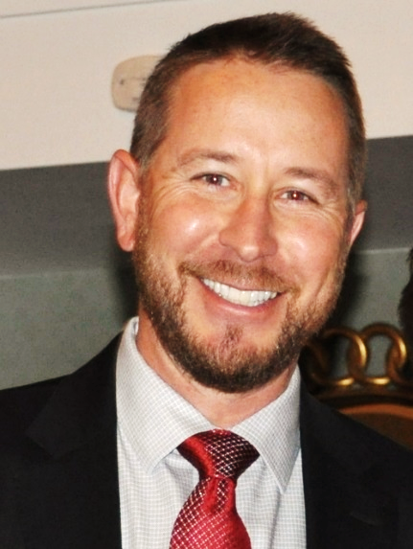
Clint Joy – Chief Operations Officer, Carolina Time and Parking Group
Clint is the Chief Operations Officer (COO) for the Carolina Time and Parking Group. He and his family reside in Charlotte, NC. His current responsibilities include the direct oversight of 7 branch offices in the Carolinas, Georgia and Virginia. With over 25 years of experience in the Parking and Transportation industry, Clint has been involved in many projects that included business development, on-street and off-street operations, infrastructure and operational policy design, large-scale transitions, and parking/transportation systems at Municipalities, Universities, Hospitals and Airports.
Clint began his parking career as a cashier in 1991, while attending Metro State University, and served many roles during his time there including parking enforcement, maintenance and special events coordinator. Ultimately, he became the Transportation Manager for the Auraria Campus in Denver, CO. At Auraria, Clint was responsible for the oversight of all Transportation and Parking operations on a campus that houses 3 Universities and over 30,000 students.
Prior to joining Carolina Time, Clint was a Senior Vice President for Standard Parking (SP Plus) with responsibility of over 30 airports and 2,000 employees in the Western U.S. In his 14 years with Standard, Clint was a Senior Manager in Los Angeles, CA and a Regional Vice President for West Airport Division. During his time at SP Plus, Clint was awarded the New Business Deal of the Year in 2004, 2008 and 2010 for the development, transition and operation of 3 separate large-scale Airport operations.
Clint is a longstanding member of the IPMI and has been affiliated with the CPMA for the last 5 years. In addition, Clint has served as a Host Committee Board member for the IPI in 2009, President and Treasurer for the AMDA from October 2015- June 2017, and the conference planning committee for the CPMA in 2017.

