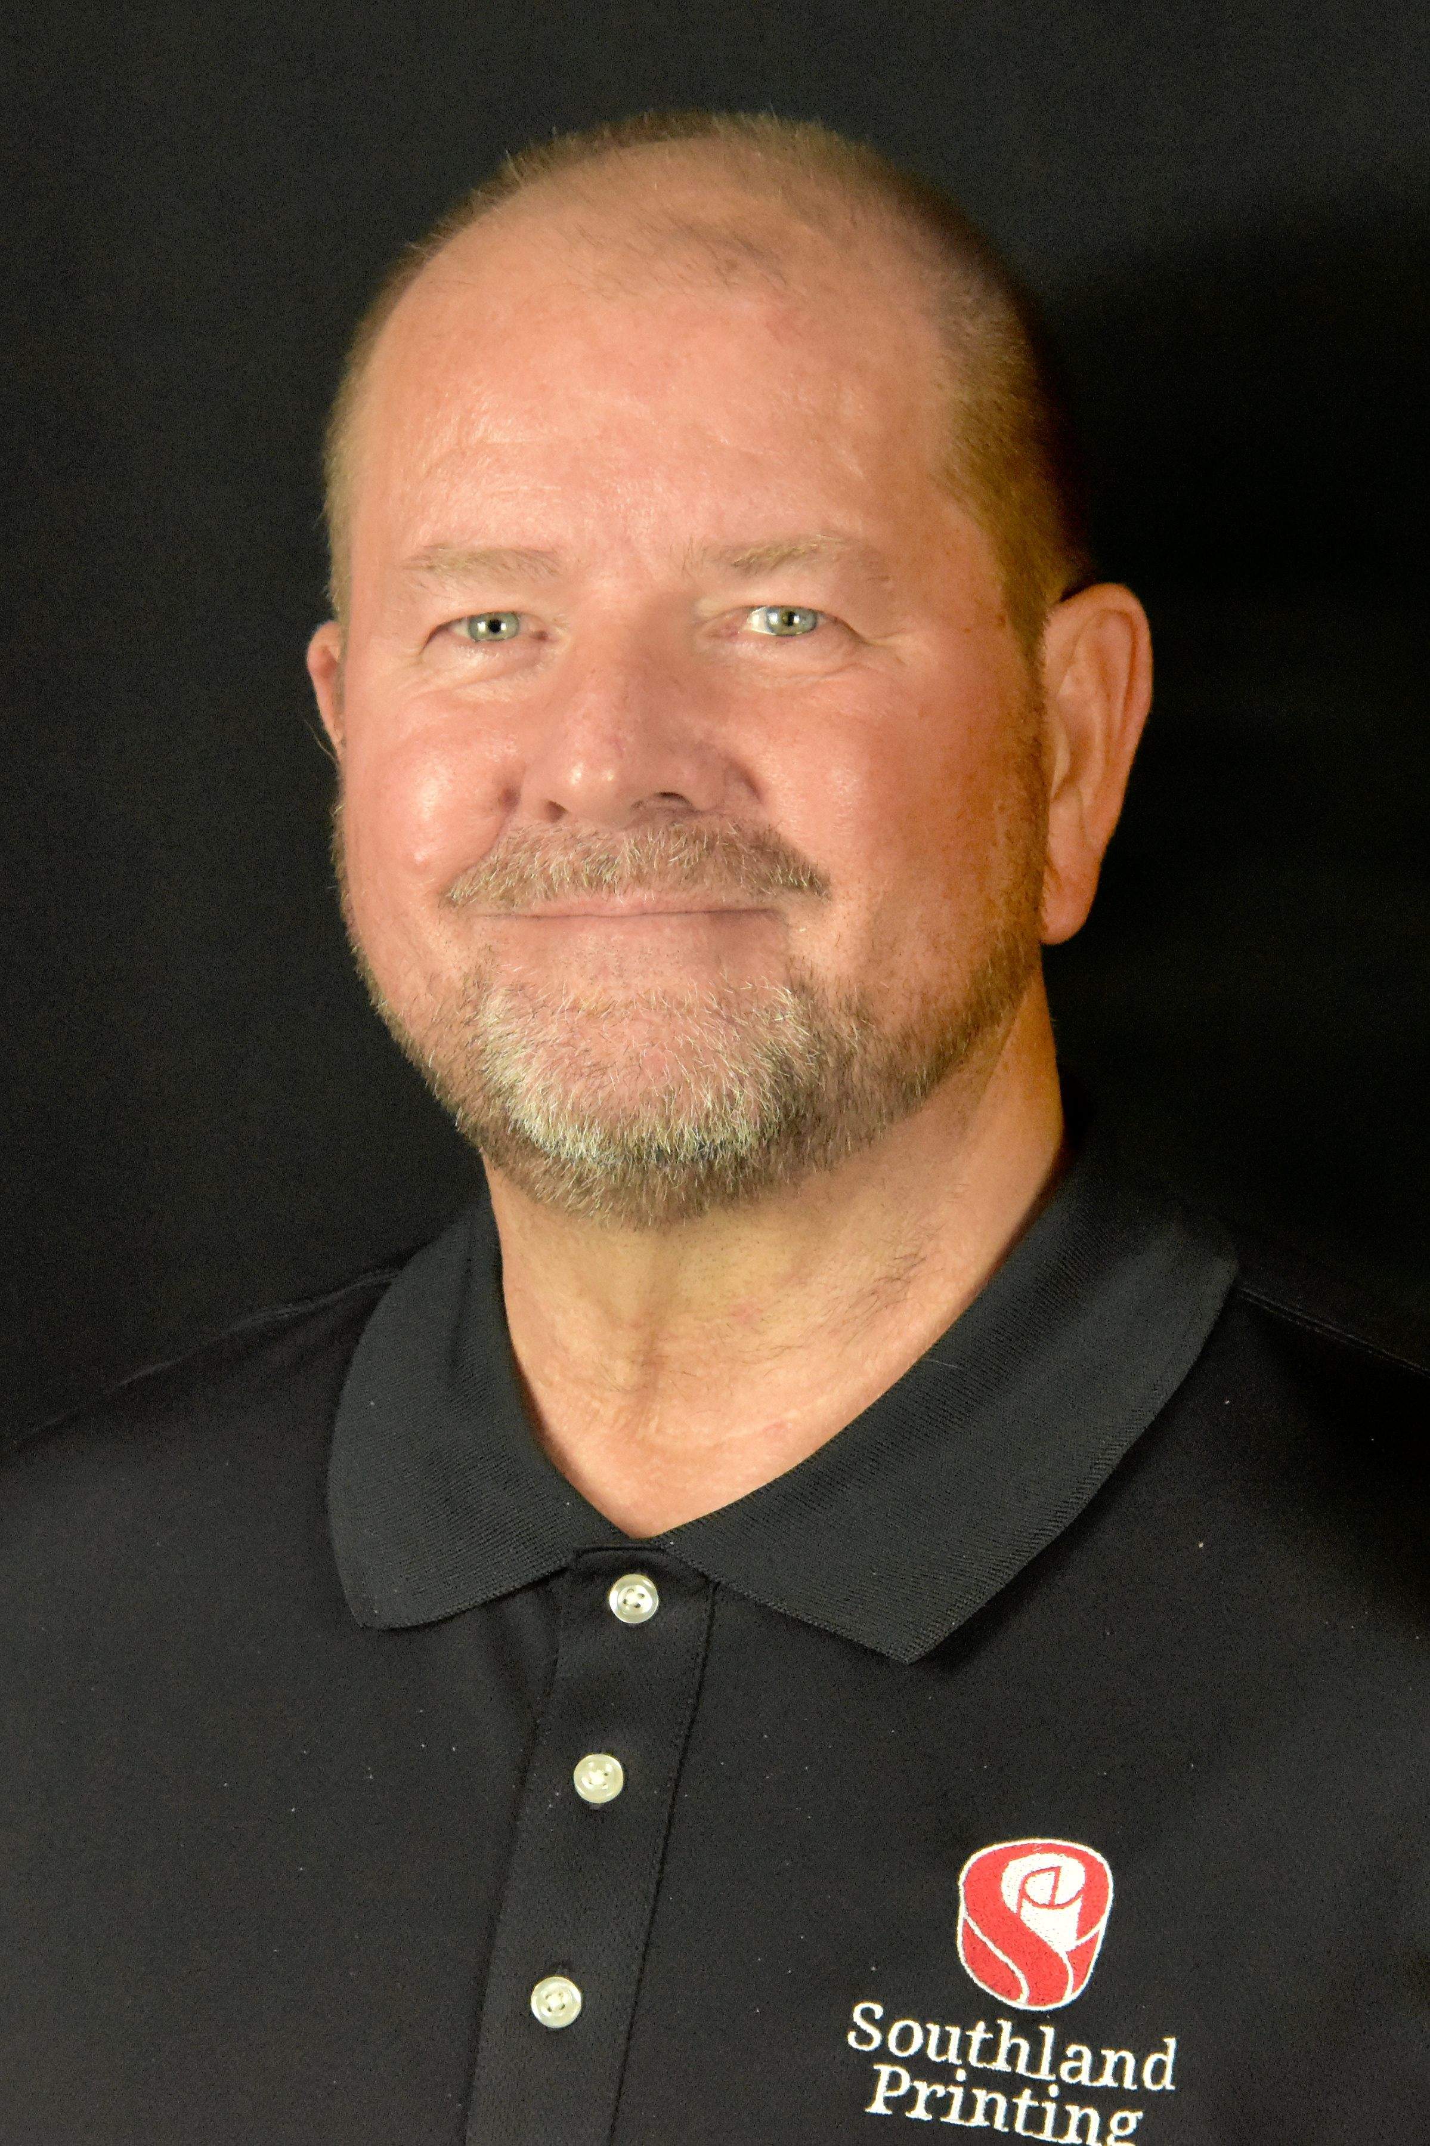

I am Gary Flowers, the Southeast Regional Sales Account Manager with Southland Printing Company, Inc. I’ve had the pleasure of working at Southland Printing for 38+ years. I currently service the Southeast Region from Florida up to Delaware. I look forward to and enjoy coming to work and being able to assist our customers with their printing needs. I like that our customers are glad to call or email me at any time they need our services. I like to believe that the Customer or Prospect sees me as a reliable source and someone with attention to detail so their orders are printed correctly and arrive on time. As my responsibility is to make our customer’s job as easy and painless as possible. Unfortunately, there are minimal instances when an issue arises, and I am always there to assist the customer these matters. I would be glad and honored to serve as a board member for the Carolinas Parking Mobility Association.

