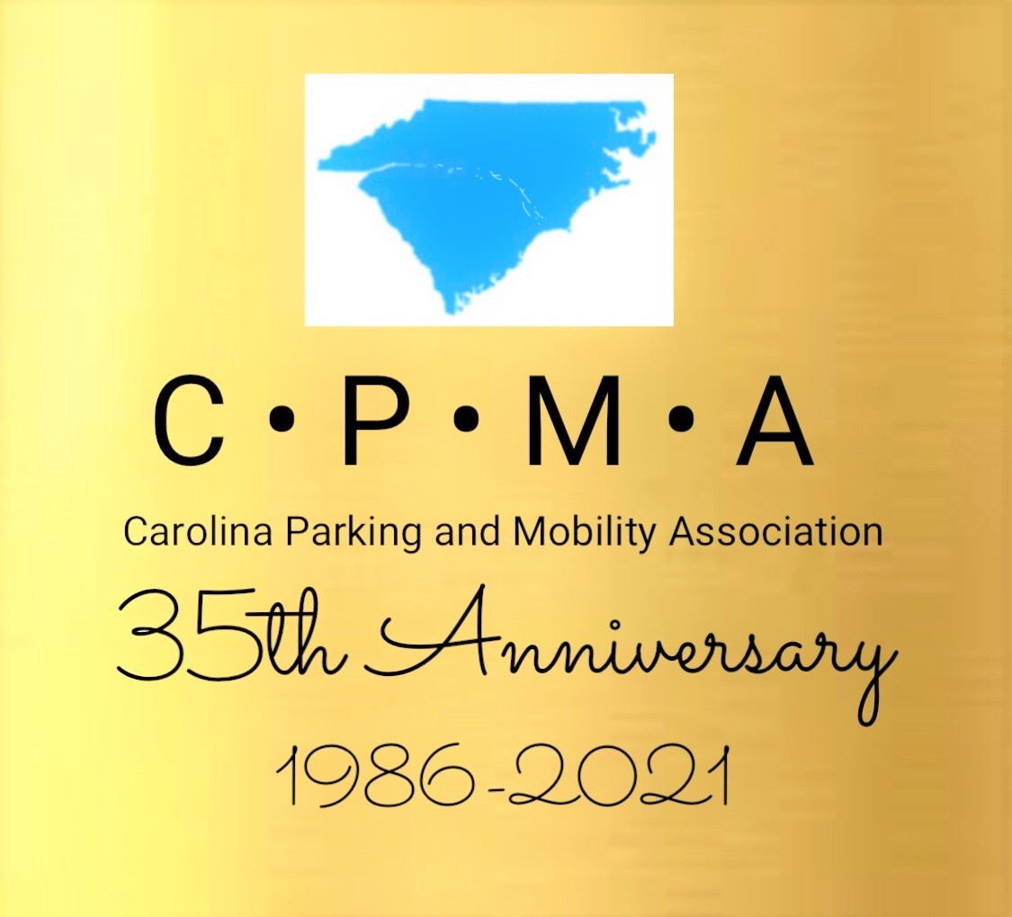
Make plans to join us in the Great Smokey Mountains (a UNESCO World Heritage Site), as leaves change from green to an incredible display of vibrant colors.
Mark your calendars and join us at the 2021 Annual Conference & Trade Show ………… October 5 – 8, 2021 at the beautiful Harrah’s Casino & Resort in Cherokee, North Carolina. Hope rises as normalcy begins to bloom!

Click on the following link to register for our best conference ever!
https://capaa.memberclicks.net/2021annualconference

We are very cognizant and respectful of the ever-changing COVID protocols and will adhere to the latest North Carolina procedures emphasizing the health and well-being of participants. The hotel issued the following: https://www.caesars.com/health-and-safety

CAROLINAS PARKING & MOBILITY ASSOCIATION

35th ANNUAL CONFERENCE & TRADE SHOW

October 5 – 8, 2021

Harrah’s Cherokee Casino Resort

777 Casino Drive

Cherokee, North Carolina 28719

www.harrahs.com

BOOK YOUR HOTEL RESERVATIONS:

https://www.caesars.com/book/?propCode=CHE&action=FindRooms&groupcode=S10CPMACall in: 828-497-7777 and use code S10CPMA – Carolinas Parking & Mobility Association

Rate: $129/night Cut-off Date for CPMA Room Block & Rate: September 10, 2021

